**Deploy the Elasticsearch (ECK) operator on OpenShift**

* In the OpenShift web console, go to the left pane and select Administrator in the dropdown menu.
* Select Operators, then OperatorHub, and search for "**Elasticsearch (ECK) Operator**":

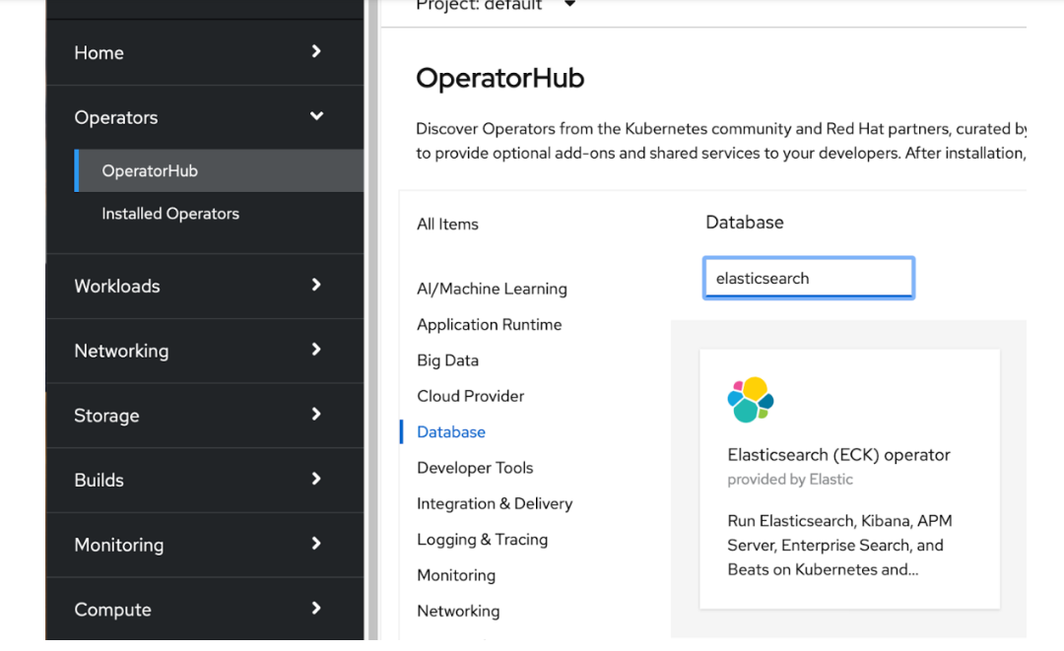

* Click on the tile (skip the community version if you want to install the certified operator). Click on Install, leave the default selection, and click again on Install.

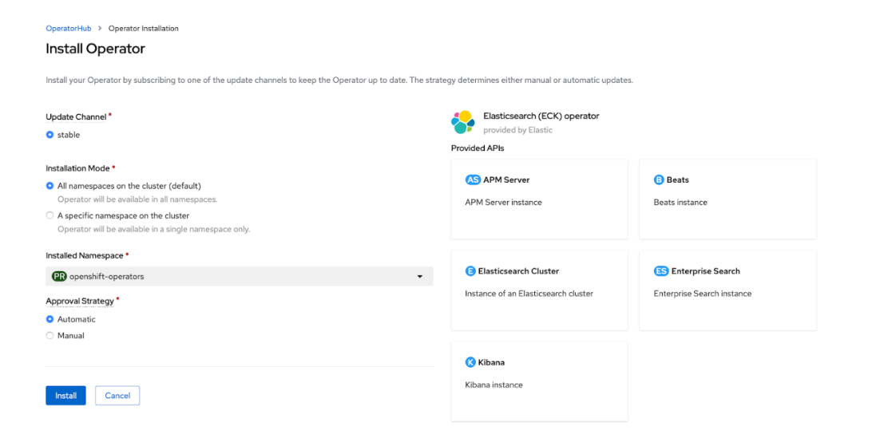

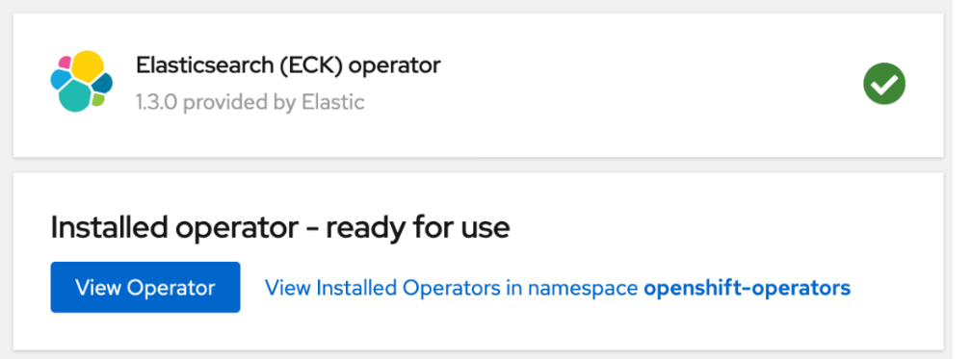

The operator is deployed in the openshift-operators namespace. To get its status from the command line, run the following command:

$ oc get pods -n openshift-operators -l control-plane=elastic-operator  
NAME                               READY   STATUS    RESTARTS   AGE  
elastic-operator-bc7bbd885-j2sth   1/1     Running   0          53m

To get the operator logs, run this command:

$ oc logs -l control-plane=elastic-operator  -n openshift-operators -f

To visualize your metrics through dashboards, deploy a Kibana instance, associated with the Elasticsearch cluster that was previously created: Deploy an Elasticsearch cluster and Kibana  
We want to deploy Elasticsearch to collect metrics from your OpenShift cluster and use Kibana to visualize them.  
Let’s deploy an Elasticsearch cluster with three data nodes. To make sure that the settings allow the Elasticsearch cluster to handle at least 100GB of data, apply [the following manifest](https://gist.githubusercontent.com/barkbay/7a4316f7a7c1e0cd3fc26c201af98ce5/raw/8f82be64568f885333350d988df043279fc757c2/elasticsearch.yaml):  
cat <<EOF | oc apply -f -  
apiVersion: elasticsearch.k8s.elastic.co/v1  
kind: Elasticsearch  
metadata:  
 name: elasticsearch  
 namespace: elastic-monitoring  
spec:  
 version: 7.10.0  
 nodeSets:  
 - name: default  
   count: 3  
   podTemplate:  
     spec:  
       containers:  
         - name: elasticsearch  
           env:  
             - name: ES_JAVA_OPTS  
               value: -Xms4g -Xmx4g  
           resources:  
             requests:  
               memory: 8Gi  
               cpu: 1  
             limits:  
               memory: 8Gi  
   volumeClaimTemplates:  
     - metadata:  
         name: elasticsearch-data  
       spec:  
         accessModes:  
           - ReadWriteOnce  
         resources:  
           requests:  
             storage: 100Gi  
         storageClassName: standard  
   config:  
     node.roles: [ "master", "data" ]  
     node.store.allow_mmap: false  
EOF

To visualize your metrics through dashboards, deploy a Kibana instance, associated with the Elasticsearch cluster that was previously created:

cat <<EOF | oc apply -f -  
apiVersion: kibana.k8s.elastic.co/v1  
kind: Kibana  
metadata:  
 name: kibana  
 namespace: elastic-monitoring  
spec:  
 version: 7.10.0  
 count: 1  
 elasticsearchRef:  
   name: elasticsearch  
EOF

With the elasticsearchRef parameter, an encrypted connection between Kibana and Elasticsearch is automatically established. Make sure that the status for both Elasticsearch and Kibana is green:

% oc get es,kb -n elastic-monitoring  
NAME                                                       HEALTH   NODES   VERSION   PHASE   AGE  
elasticsearch.elasticsearch.k8s.elastic.co/elasticsearch   green    3       7.10.0    Ready   52m  
  
NAME                                  HEALTH   NODES   VERSION   AGE  
kibana.kibana.k8s.elastic.co/kibana   green    1       7.10.0    48m

Notes: <https://www.redhat.com/en/blog/run-elastic-cloud-on-kubernetes-on-red-hat-openshift>